CNS 1410 Object-oriented Programming

Programming Project 8: A Stack of Integers

Due Date:
Must be submitted no later than 1:00am on Monday.
Programs received prior to 1:00am on Sunday will receive 5 bonus points, if the program completely meets the specifications and executes correctly.

Objective:
- To give student's experience constructing a program that must manage dynamically allocated memory.
- To help students understand how a stack operates.


Background:
In this project, you will create a class that represents a Stack of integers. A Stack is a data structure that retrieves data in the reverse order from which it was stored. Access is limited to the top element on the stack. A good analogy for a stack is the plate dispenser you often see in a cafeteria line. When the dishwasher brings out a clean plate and puts it in the dispenser, the current top plate gets pushed down and the new plate becomes the top one. When a customer in the cafeteria line picks up the top plate, the next plate in the stack pops up and becomes the new top plate.
A stack is often represented internally by an array. Functions typically provided with a Stack are
- push ( value ) puts the value on top of the stack. Like the plate dispenser, all elements currently on the stack are pushed down one place.
- pop ( ) removes the top element from the stack, but does not return it. The next element on the stack becomes the new top element.
- top ( ) returns the value of the top element on the stack, but leaves the element on the stack.

The Stack Class
In the project, you are to design a Stack class that grows as needed. Your stack class should contain a dynamically allocated array of integers. Implement the stack functions
- void push ( int ),
- void pop ( ), and
- int top ( )
by manipulating an index into the array. One problem with a stack is that it can become full, so no more values can be pushed onto it. When this situation occurs, your Stack class should provide a mechanism that
- Dynamically allocates storage for a larger array of integers,
- Copies all of the values from the old array into the new one, and
- Deletes the old array.
Be sure that you use the memory management techniques taught in the lecture on "Engineering Classes".

Program
Write a Program that implements the Stack class you designed. The driver should test your Stack class by pushing a large number of elements onto the stack, then take each element off of the stack and print its value.
Your program should:
- Contain a well-designed Stack class that
  - Includes the functions push, pop, and top as described above (15 points )
  - Initially contains space for 5 elements, but grows as required to contain more. Dynamically allocated memory is properly managed so that your program has no memory leaks (10 points)
  - Includes a correctly working overloaded assignment operator (10 points)
  - Includes a correctly working copy constructor (10 points)
  - Includes a correctly working destructor (10 pts)
- Verify your implementation by writing a main driver that
  - Creates an array of 12 integer values. Print the contents of the array ( 5 points )
  - Create a Stack object using the default constructor. Then provide a loop that pushes each element of the array onto the stack in turn. This should cause the stack size to expand more than once (5 points)
  - Create a second loop that displays each value on the stack by displaying the value of the top element on the stack, and then popping that element from the stack. Continue until all elements have been removed from the stack. (10 points).
  - Push several new values onto the stack, to use in the next two steps.
  - To test the overloaded assignment operator, create a second stack object and assign the first to the second. Print out the contents of the second stack to verify that the assignment worked.
  - To test the copy constructor, pass a Stack object to a function that will return the sum of the elements in the stack. Be sure to pass the stack object by value.
Format and document your code in accordance with the course style guidelines. Include a file prologue identifying you as the author. Submit your project using the instructions outlined in the Course Syllabus, Programming Projects section.

File(s) to Submit:
All source code files and an executable file.

Grading
You should include your UML diagram in your submission to WebCT. The Grade sheet is here

Sample Output:
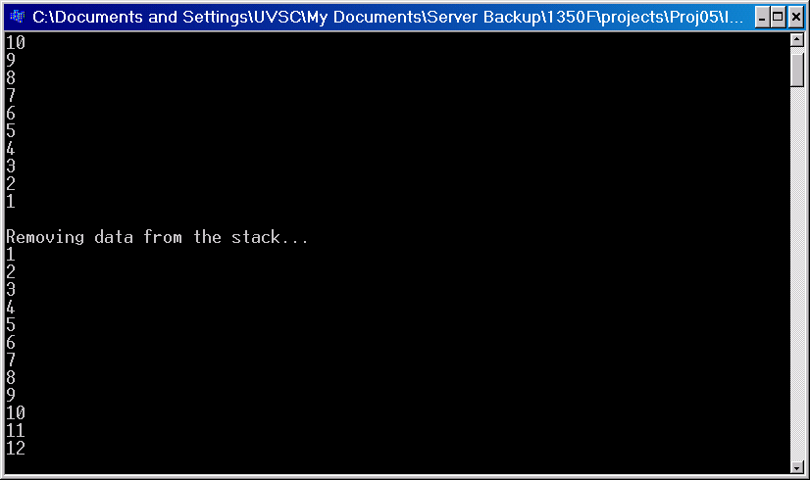

Sample Executable
The managed stack program

